Задачи от упражнение 2
Иван Дамянов, група 55

Зад. 1
#Exercise 1
evensum = 0
evencount = 0
oddsum = 0
oddcount = 0

for i in range(0, 10):
num = int(input("num = "))
if num % 2 == 0:
evensum += num
evencount += 1
else:
oddsum += num
oddcount += 1

print(f"\nTotal sum of even numbers: {evensum}")
print(f"Total sum of odd numbers: {oddsum}\n")

evensum /= evencount
oddsum /= oddcount
print(f"Аrithmetic mean value of even numbers: {evensum}")
print(f"Arithmetic mean value of odd numbers: {oddsum}\n")

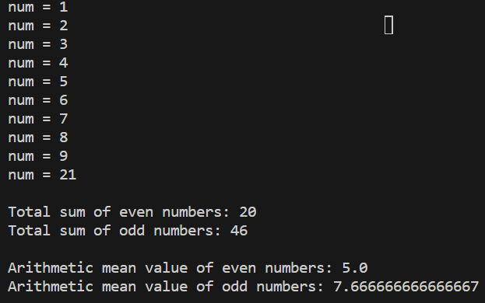
Зад. 2
#Exercise 2
counter = 0
i_even = 0

for i in range(0,10):
num = int(input("num = "))

if num % 2 == 0 and counter == 0:
min = num
counter = 1

if num % 2 == 0 and counter == 1:
i_even += 1
if min > num:
min = num

print(f"min = {min}")
print(f"counter = {i_even}")

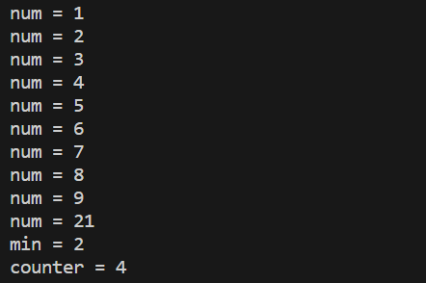

Зад. 3
#Exercise 3
counter = 0
i_even = 0

for i in range(0,10):
num = int(input("num = "))

if num % 2 != 0 and counter == 0:
max = num
counter += 1

if num % 2 != 0 and counter == 1:
i_even += 1
if num > max:
max = num

print(f"max = {max}")
print(f"counter = {i_even}")

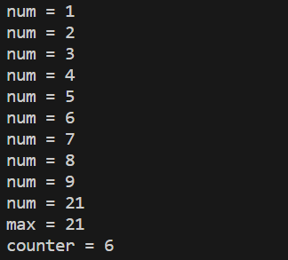

Зад. 4
#Exercise 4
total_n = 0
in_bounds_n = 0
sum = 0
while True:

min = int(input("Minimum num: "))
max = int(input("Maximum num: "))
if min < max:
break
else:
print("Impossible limits!")

for i in range(0, 10):
num = int(input("num = "))
total_n += 1
if num >= min and num <= max:
in_bounds_n += 1
sum += num

print(f"Total numbers: {total_n}")
print(f"Numbers in boundries: {in_bounds_n}")
print(f"Sum of all numbers in boundries: {sum}")

